Create Onboarding Project Database

Open SQL Server Management Studio, connect to your SQL Server. Credentials for SQL Server is:
IP: 192.168.100.23
Username: sa
Password: 1qaz!QAZ
Create new database and name it as “SixtyThreeBitsOnboardingYourName”

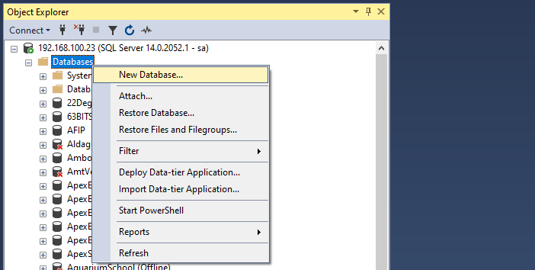

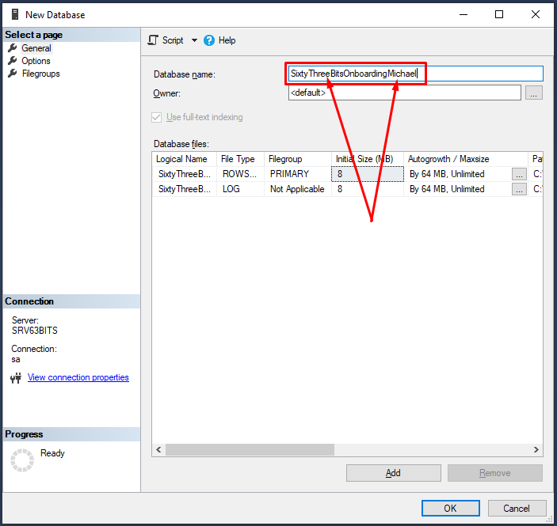
Now right click on your new database and choose “New Query”. New query window will be opened for you.
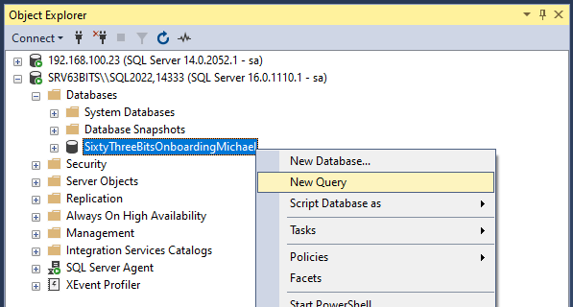

Go to your hard drive and open SixtyThreeBitsOnboarding.sql file. Copy all scripts from this file and paste it into “New query window”. It should look something like this:

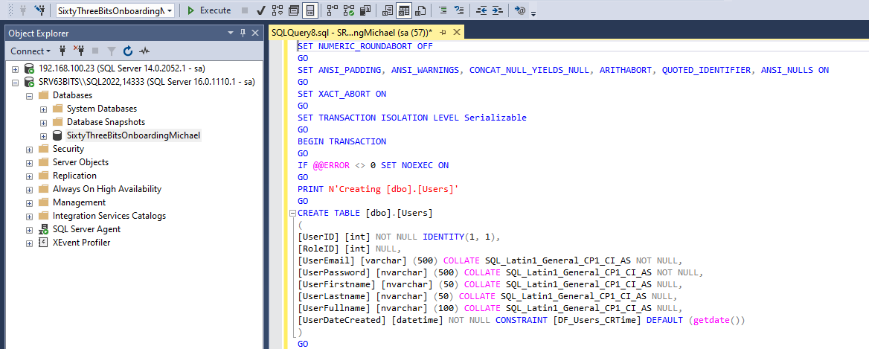

Make sure you have selected your database for the "New query window" and then click the Execute button:

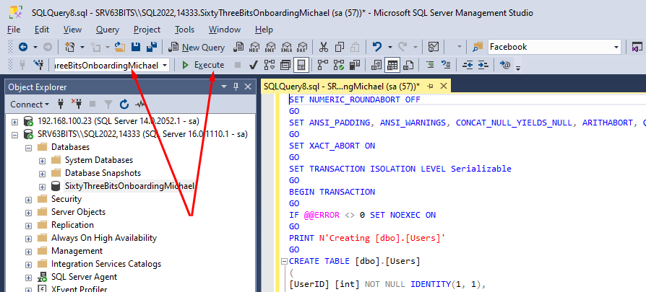

This script is designed to create a standardised database structure, including tables, stored procedures, and functions.

